
Computer Networks
CSA07
ASSIGNMENT 1
Make the Data of a Smart Manufacturing Plant Arrive Correctly and On Time
Name : S.Sri Adithya
Register No : 1911260231
Program : CSE (CORE)
Faculty : Dr. Santhiya Lakshmi
Submission Date : 2/11/26
GitHub Repository Link

https://github.com/saladiadithya8/CSA0708-Computer-networks.git

Computer Networks
ASSIGNMENT 1
CO1: Apply the functions of the OSI layers in enabling reliable data transmission across networks – uses of networks, network hardware and software, components, types of connections, topologies, protocols and standards, the ISO/OSI reference model, transmission media, wireless communication, Ethernet configuration, an introduction to 5G networks, and error detection, error correction and data-link control.

Assignment Title: Make the Data of a Smart Manufacturing Plant Arrive Correctly and On Time (Total Marks - 50)
Nature of Assignment: Individual
Duration: 1 Week
Submission Date: 2/11/26
GitHub Repository Link: https://github.com/yogeshwaran-sys/CSA0708-COMPUTER-NETWORKS-

Scenario — Network for a Smart Manufacturing Plant
An automobile-parts company is building a smart plant. Robots on the shop floor must receive control commands within 10 milliseconds; hundreds of sensors report temperature and vibration; CCTV cameras stream video; office staff use the ERP system and e-mail; and the plant exchanges production data with the head office 400 km away.
The contractor proposes ordinary office Wi-Fi throughout the plant and a single broadband connection to the head office. The plant engineers are worried that electrical noise from welding machines will corrupt data, that robot commands will be delayed, and that the head-office link will be too slow.
The network may grow:
1 production line (40 devices) → 1 plant (1,500 devices) → 5 plants connected to the head office
Each task below gives you data from the plant. Use it to calculate, compare and decide – a correct answer must be supported by your working, not only stated.
Design Challenge:
The company plans to use a private 5G network on the shop floor and to connect autonomous guided vehicles (AGVs).
Re-evaluate your original design and determine whether it should be retained, modified or redesigned.

TASK 1 – Size the Traffic Before Choosing Anything
One production line generates the following traffic:
Source | Quantity | Traffic
Robot controllers | 40 | 200-byte command every 2 ms each
Vibration sensors | 600 | 50 bytes per second each
CCTV cameras | 24 | 4 Mbps each (continuous)
Office users | 150 | 2 Mbps each at peak, 10% active at a time

Work out:
- The total traffic of one line in Mbps, and of the plant if there are 8 lines
- Which source sends the most data and which has the strictest delay requirement – are they the same?
- Whether a single 1 Gbps uplink from the shop floor is enough, and what happens to robot commands if the CCTV traffic shares the same queue
- A ranking of the traffic types by how harmful a 100 ms delay would be, with a reason for each

Alternative Concept Analysis
Suppose the CCTV cameras recorded locally and sent only motion-triggered clips (about 5% of the time) instead of streaming continuously. Recalculate the line traffic, and decide whether the 1 Gbps uplink is still the bottleneck.
Evidence Expected
Complete calculations with units, a delay-versus-volume comparison and a justified ranking.

TASK 2 – Count the Domains in the Contractor’s Drawing
The contractor’s drawing for the office block shows: three hubs with 8 PCs each, all three hubs connected to one 24-port switch, the switch connected to router interface G0/0, and router interface G0/1 connected to a second switch with 12 IP phones.
Work out:
- The number of collision domains and broadcast domains, with a marked drawing
- The OSI layer at which each device works, and why a hub cannot stop collisions
- Which connections are point-to-point and which are multipoint
- Which standard and which body defines each of: Ethernet (IEEE 802.3), Wi-Fi (IEEE 802.11), IPv4 (IETF RFC 791), the OSI model (ISO 7498), and 5G (3GPP/ITU) – and why the plant should buy only standard-compliant equipment

Alternative Concept Analysis
A colleague proposes replacing the three hubs with three cheap unmanaged switches. Recount the collision and broadcast domains, and state what this change fixes and what it does not.
Evidence Expected
Correct domain counts on a marked drawing, device-layer reasoning and a completed standards table.
Output screenshot:
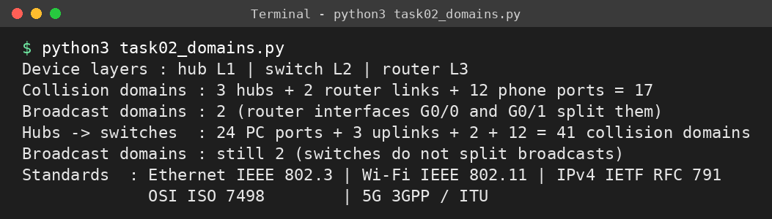

TASK 3 – Read a Captured Frame Layer by Layer
A capture of one robot command shows the following fields:
Ethernet II Dst: 00:1d:9c:c7:b0:41 Src: 3c:52:82:4e:11:07 Type: 0x0800
IPv4 Src: 10.10.1.25 Dst: 10.10.9.4 TTL: 61 Protocol: 6 (TCP)
TCP Src Port: 51522 Dst Port: 502 (Modbus) Seq: 1201 Ack: 88 Len: 12
Data 12 bytes (Modbus write-register command)

Work out:
- The OSI layer and the protocol data unit (frame, packet, segment, data) of each line
- How many routers the packet crossed if the controller sets TTL to 64
- The total bytes on the wire (include the 4-byte FCS) and the percentage that is overhead; then repeat for a 1,400-byte camera packet – what does this tell you about small commands?
- Which layer is responsible when (a) the MAC address is wrong, (b) the TTL reaches 0, (c) the destination port is closed
- How the TCP/IP model maps onto these seven layers

Output screenshot (capture calculations):
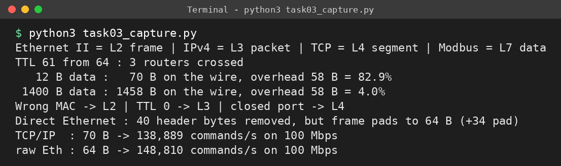
Complete the Code
Complete TODO 1 below, and run the program with Python 3.
"""How data is wrapped by each layer at the sender and unwrapped at the receiver."""
LAYERS = [("Application", "HTTP"), ("Transport", "TCP"), ("Network", "IP"),
("Data link", "ETH")]

def send(message):
pdu = message
for layer, tag in LAYERS:
# Step 1: Wrap pdu with this layer's header "[tag|" and, for the data link layer
# only, also a trailer "|FCS]"; for other layers close with "]". Print the
# layer name and the size of the new PDU
if tag == "ETH":
pdu = "[" + tag + "|" + pdu + "|FCS]"
else:
pdu = "[" + tag + "|" + pdu + "]"
print(f"{layer:<13}adds {tag:<4} -> {len(pdu):>3} bytes")
return pdu

def receive(frame):
pdu = frame
for layer, tag in reversed(LAYERS):
head = "[" + tag + "|"
tail = "|FCS]" if tag == "ETH" else "]"
assert pdu.startswith(head) and pdu.endswith(tail), f"{layer}: bad header"
pdu = pdu[len(head):-len(tail)]
return pdu

frame = send("GET /results")
print("on the wire:", frame)
print("delivered :", receive(frame))
print(f"overhead : {len(frame) - len('GET /results')} bytes for 12 bytes of data")
Output screenshot:
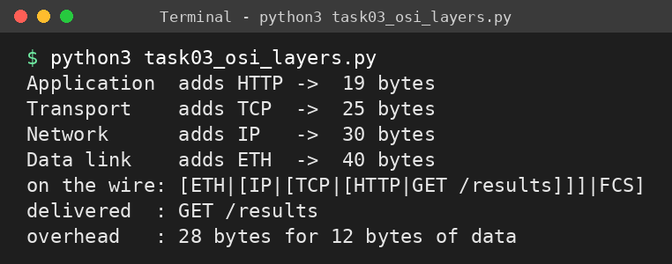
Expected output:
Application adds HTTP -> 19 bytes
Transport adds TCP -> 25 bytes
Network adds IP -> 30 bytes
Data link adds ETH -> 40 bytes
on the wire: [ETH|[IP|[TCP|[HTTP|GET /results]]]|FCS]
delivered : GET /results
overhead : 28 bytes for 12 bytes of data

Change the message to 1,400 bytes and compare the overhead percentage with the 12-byte message.
Alternative Concept Analysis
An industrial protocol could carry the robot command directly inside an Ethernet frame (EtherType 0x8892) with no IP or TCP header. Calculate the bytes saved per command and the commands per second this frees on a 100 Mbps link, and identify what the plant loses by giving up IP.
Evidence Expected
A layer-by-layer reading of the capture, correct overhead calculations and a fault-to-layer mapping.

TASK 4 – Choose a Medium for Each Run (There Is a Trap)
The plant has four cable runs: (a) a robot cell next to arc-welding machines, 85 m; (b) the office floor to the shop-floor switch, 140 m; (c) the shop floor to the data centre, 550 m; (d) the plant to the head office, 400 km.
Work out:
- A medium for each run (Cat6 UTP, Cat6A S/FTP, multimode fibre, single-mode fibre, leased line or wireless) with the deciding reason
- Which run cannot use copper Ethernet at all, and why (look at the distance limits)
- The Shannon capacity of a 250 MHz cable with an SNR of 40 dB and of the same cable near the welders with an SNR of 15 dB – what does the difference mean for the robot cell?
- Why the speed measured on a link is always below the Shannon limit

Complete the Code
Complete TODO 1 and TODO 2 below, and run the program with Python 3.
"""Nyquist and Shannon limits for the transmission media proposed for a campus."""
import math

def nyquist(bandwidth_hz, levels):
# Step 1: Return the Nyquist maximum bit rate for a noiseless channel: 2 x bandwidth
# x log2(levels)
return 2 * bandwidth_hz * math.log2(levels)

def shannon(bandwidth_hz, snr_db):
# Step 2: Convert the SNR from decibels to a ratio (10 ** (dB / 10)) and return the
# Shannon capacity: bandwidth x log2(1 + SNR)
snr = 10 ** (snr_db / 10)
return bandwidth_hz * math.log2(1 + snr)

media = [("Telephone line", 3_100, 30), ("Cat6 pair", 250e6, 40),
("Wi-Fi 6 channel", 160e6, 25)]
for name, bw, snr in media:
print(f"{name:<16} Shannon limit {shannon(bw, snr) / 1e6:10.2f} Mbps")
print(f"Nyquist, 3,100 Hz with 4 levels: {nyquist(3_100, 4) / 1e3:.1f} kbps")
Output screenshot:
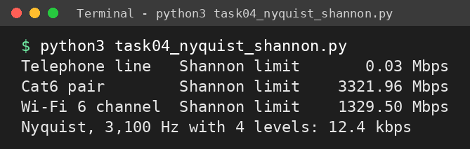
Expected output:
Telephone line Shannon limit 0.03 Mbps
Cat6 pair Shannon limit 3321.96 Mbps
Wi-Fi 6 channel Shannon limit 1329.50 Mbps
Nyquist, 3,100 Hz with 4 levels: 12.4 kbps

Find the SNR (in dB) a 3,100 Hz telephone line would need to carry 56 kbps, and judge whether that is realistic.
Alternative Concept Analysis
What if the robot cell used Wi-Fi 6 instead of shielded cable? Using the welding-area SNR of 15 dB on a 160 MHz channel, calculate the Shannon limit, and decide whether a wireless link is acceptable for 10 ms robot commands.
Evidence Expected
A justified medium for every run, the trapped run identified, and Shannon calculations with interpretation.

TASK 5 – Wi-Fi 6 or 5G for Moving Equipment?
An AGV travels at 2 m/s along a 1.2 km route. Wi-Fi access points are 30 m apart, and a Wi-Fi hand-over takes about 150 ms. A private 5G cell covers 300 m, and a 5G hand-over takes about 20 ms. AGV commands have a 10 ms deadline.
Work out:
- The number of hand-overs per trip for Wi-Fi and for 5G, and the total time per trip during which the AGV is not reachable
- Which of the three 5G service types (eMBB, URLLC, mMTC) the AGVs, the cameras and the sensors each need
- Where Bluetooth, Zigbee or LoRa would be a better choice than Wi-Fi or 5G in the plant
- Whether Wi-Fi 6 with fast roaming (802.11r) could meet the deadline – and what remains risky

Alternative Concept Analysis
The sensors could use LoRaWAN (a few kbps, kilometres of range, years on a battery) instead of Wi-Fi. Calculate whether 600 sensors at 50 bytes per second fit within one LoRa gateway’s capacity of roughly 5 kbps, and decide which sensors should stay on Wi-Fi.
Evidence Expected
Hand-over calculations, a mapping of traffic to 5G service types and a justified wireless decision.
Output screenshot:
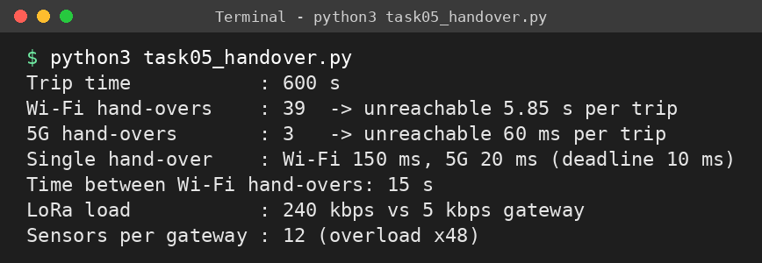

TASK 6 – Interpret an Ethernet Port Report
A shop-floor PC is slow. Its network interface reports:
Speed: 100Mb/s Duplex: Half Auto-negotiation: off
Link detected: yes rx_errors: 2381 late_collisions: 412 crc_errors: 1907

Work out:
- What a late collision and a CRC error each mean, and what the combination suggests about the two ends of the link
- The likely cause (a duplex mismatch with a gigabit switch port set to auto) and the exact configuration change on Linux (ethtool) or Windows
- Whether the MAC address 01:00:5e:0a:01:02 belongs to a single device or a group, and what the first three bytes of 3c:52:82:4e:11:07 identify
- Whether jumbo frames (9,000 bytes) would help the CCTV storage server, and what must also change for them to work

Alternative Concept Analysis
Compare a shop floor wired as a ring of industrial switches with fast ring recovery against a star of switches. For one cable cut, state the recovery time each needs and which devices lose connection.
Evidence Expected
A reasoned interpretation of the report, the corrective configuration and correct answers on addressing and frame size.
Output screenshot:
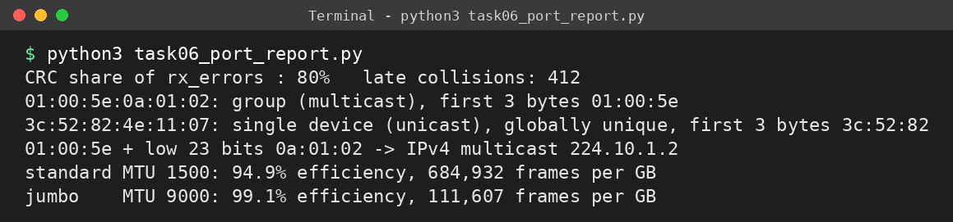

TASK 7 – Will the Receiver Notice the Error?
Frames between two shop-floor switches are protected by a CRC with generator 1011 (x³ + x + 1).
Work out:
- The CRC bits for the data 1101011011, by hand (show the division)
- Whether a received frame 1101011011101 is accepted or rejected
- The longest burst error this generator is certain to detect, and an error pattern it cannot detect
- The two-dimensional parity of a 4 × 4 block of your choice, and a 4-bit error pattern that two-dimensional parity misses
- The Internet checksum of the four 16-bit words 4500, 0073, 0000, 4000 (hexadecimal)

Complete the Code
Complete TODO 1 below to finish the modulo-2 division, and run the program with Python 3.
"""CRC error detection for frames sent between two switches."""
def mod2_div(dividend, divisor):
"""Return the remainder of modulo-2 (XOR) division of two bit strings."""
rem = list(dividend)
for i in range(len(dividend) - len(divisor) + 1):
# Step 1: If the current leading bit rem[i] is 1, XOR the divisor into rem
# starting at position i
if rem[i] == "1":
for j in range(len(divisor)):
rem[i + j] = "0" if rem[i + j] == divisor[j] else "1"
return "".join(rem[-(len(divisor) - 1):])

def encode(data, gen):
crc = mod2_div(data + "0" * (len(gen) - 1), gen)
return data + crc

def check(frame, gen):
return set(mod2_div(frame, gen)) == {"0"}

GEN = "1011" # x^3 + x + 1
frame = encode("1101011011", GEN)
print("transmitted:", frame)
print("no error :", check(frame, GEN))
bad = frame[:4] + ("1" if frame[4] == "0" else "0") + frame[5:]
print("1-bit error:", check(bad, GEN))
burst = frame[:2] + "".join("1" if b == "0" else "0" for b in frame[2:5]) + frame[5:]
print("3-bit burst:", check(burst, GEN))
Output screenshot:
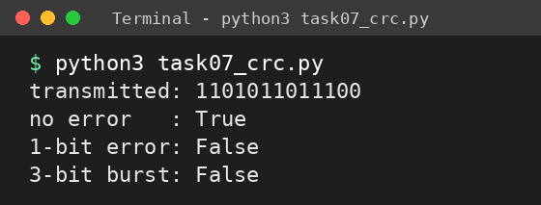
Expected output:
transmitted: 1101011011100
no error : True
1-bit error: False
3-bit burst: False

Find, with the program, an error pattern that generator 1011 cannot detect, and explain why.
Alternative Concept Analysis
Which errors would a simple even-parity bit catch that the CRC-3 generator 1011 misses, and which would it miss? Give one 2-bit and one 4-bit error pattern for each method and state the result.
Evidence Expected
Hand calculations with working, an undetected-error example for each method and a comparison of their strength.

TASK 8 – Correct the Error or Ask Again?
A vibration sensor sends 16-bit readings over a noisy radio link where retransmission takes 40 ms.
Work out:
- The number of Hamming check bits needed for a 16-bit word (use 2ʳ ≥ m + r + 1) and the overhead percentage
- The minimum Hamming distance of the code {00000, 01011, 10101, 11110}, and how many errors it can detect and correct
- The corrected data when the Hamming(7,4) codeword 0110011 arrives as 0110111
- Whether forward error correction or retransmission (ARQ) suits this link, and why video streaming and 5G use FEC

Complete the Code
Complete TODO 1 below, and run the program with Python 3.
"""Hamming(7,4) code: correct a single-bit error in a 4-bit sensor reading."""
def encode(d): # d = [d1, d2, d3, d4]
p1 = d[0] ^ d[1] ^ d[3]
p2 = d[0] ^ d[2] ^ d[3]
p3 = d[1] ^ d[2] ^ d[3]
return [p1, p2, d[0], p3, d[1], d[2], d[3]] # positions 1..7

def decode(c):
# Step 1: Compute the syndrome bits s1 (positions 1,3,5,7), s2 (2,3,6,7) and s3
# (4,5,6,7); pos = s1 + 2*s2 + 4*s3. If pos is not 0, flip bit pos (index pos-1).
# Return pos and the data bits at positions 3, 5, 6, 7
s1 = c[0] ^ c[2] ^ c[4] ^ c[6]
s2 = c[1] ^ c[2] ^ c[5] ^ c[6]
s3 = c[3] ^ c[4] ^ c[5] ^ c[6]
pos = s1 + 2 * s2 + 4 * s3
c = c[:]
if pos != 0:
c[pos - 1] ^= 1
return pos, [c[2], c[4], c[5], c[6]]

word = encode([1, 0, 1, 1])
print("codeword :", "".join(map(str, word)))
for flip in (None, 5):
rx = word[:]
if flip:
rx[flip - 1] ^= 1
pos, data = decode(rx)
print(f"error at {str(flip):<4}: syndrome {pos}, data {''.join(map(str, data))}")
Output screenshot:
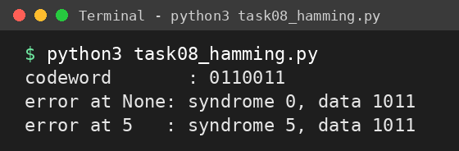
Expected output:
codeword : 0110011
error at None: syndrome 0, data 1011
error at 5 : syndrome 5, data 1011

Flip two bits of the codeword and show that the decoder now “corrects” the wrong bit.
Alternative Concept Analysis
At a bit-error rate of 1 in 1,000, compare sending 16-bit readings with Hamming correction against retransmitting on error: calculate the bits sent per reading and the average delay for each, using the 40 ms retransmission time.
Evidence Expected
Correct calculations, a corrected codeword and a justified choice between FEC and ARQ.

TASK 9 – How Big Must the Window Be?
The head-office link is 400 km of fibre at 1 Gbps; frames are 1,500 bytes; light travels at 2 × 10⁸ m/s in fibre.
Work out:
- The transmission time, the propagation time and the ratio a = propagation / transmission
- The link utilisation with stop-and-wait ARQ – and what it means in Mbps
- The smallest window that keeps the link fully used, and the number of sequence-number bits needed for Go-Back-N and for Selective Repeat with that window
- Which of the two ARQ protocols resends fewer frames after one loss, and what it costs the receiver
- How HDLC or PPP frames mark the start and end of a frame

Complete the Code
Complete TODO 1 below, and run the program with Python 3.
"""Link utilisation of stop-and-wait and sliding-window protocols on different links."""
def utilisation(frame_bits, rate_bps, distance_m, window, speed=2e8):
tx = frame_bits / rate_bps # transmission time
prop = distance_m / speed # propagation time
# Step 1: a = prop / tx. Utilisation is window / (1 + 2a), but never more than 1.
# Return the utilisation and a
a = prop / tx
return min(1, window / (1 + 2 * a)), a

links = [("Campus LAN, 200 m, 1 Gbps", 1e9, 200),
("City fibre, 50 km, 1 Gbps", 1e9, 50_000),
("Satellite, 36,000 km, 10 Mbps", 10e6, 36_000_000)]
for name, rate, dist in links:
u1, a = utilisation(12_000, rate, dist, 1)
u7, _ = utilisation(12_000, rate, dist, 7)
u127, _ = utilisation(12_000, rate, dist, 127)
print(f"{name:<31} a = {a:7.2f} stop-and-wait {u1:6.1%} "
f"W=7 {u7:6.1%} W=127 {u127:6.1%}")
Output screenshot:
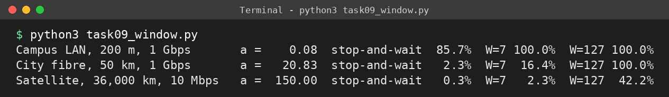
Expected output:
Campus LAN, 200 m, 1 Gbps a = 0.08 stop-and-wait 85.7% W=7 100.0% W=127 100.0%
City fibre, 50 km, 1 Gbps a = 20.83 stop-and-wait 2.3% W=7 16.4% W=127 100.0%
Satellite, 36,000 km, 10 Mbps a = 150.00 stop-and-wait 0.3% W=7 2.3% W=127 42.2%

Calculate the smallest window that gives 100% utilisation on the satellite link.
Alternative Concept Analysis
Suppose the head-office link used Selective Repeat with a window of 64 instead of the window you calculated. Calculate the resulting utilisation and throughput, and the receiver buffer space needed.
Evidence Expected
Correct timing, utilisation and window calculations, sequence-number sizes and a justified protocol choice.

TASK 10 – Find Where the Delay Comes From
A traceroute from the plant to the head-office server gives:
1 10.10.1.1 0.6 ms 0.5 ms 0.6 ms
2 100.64.0.1 3.1 ms 2.9 ms 3.4 ms
3 172.31.4.9 4.0 ms 38.2ms 4.2 ms
4 103.21.8.17 11.8 ms 11.5ms 12.1ms
5 * * *
6 10.200.0.10 12.6 ms 12.4ms 12.9ms

Work out:
- The propagation delay you would expect for 400 km of fibre, and how much of the measured delay it explains
- Why hop 3 shows one value of 38.2 ms, and why hop 5 shows only stars – are they faults?
- Which hop adds the most delay
- Your own traceroute, ping and Wireshark capture of a real connection, with the headers of each layer identified

Alternative Concept Analysis
Compare continuous monitoring with SNMP counters and flow records (NetFlow) against occasional ping and traceroute tests: which of the problems in the traceroute above would each have detected, and how quickly?
Evidence Expected
A reasoned reading of the traceroute, a propagation-delay check and your own measured evidence.
Output screenshot:
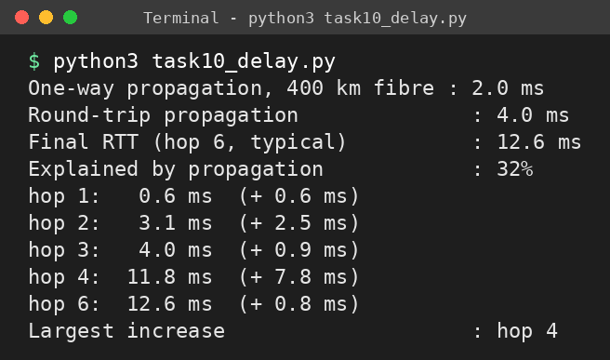

TASK 11 – Defend the Network Design
Recommend the network design for the plant.
Work out:
- The medium, wireless technology and Ethernet settings for each area
- The error-control and flow-control method for each link, with the calculation that justifies it
- The two biggest risks that remain in your design
- Whether your design still works for five plants

Your recommendation must quote numbers from Tasks 1–10.
Alternative Concept Analysis
Suppose the whole plant used private 5G instead of a wired backbone with Wi-Fi. Using your traffic figures from Task 1, decide which traffic 5G should carry and which must stay on cable, and justify the split.
Evidence Expected
A recommendation supported by your own calculations and measurements.

TASK 12 – Re-evaluate and Adapt the Design
Changed Requirement
The company adds a private 5G network on the shop floor and 50 AGVs that move parts between lines and must never miss a command.
Re-evaluate your original design. You may RETAIN → MODIFY → or REDESIGN your original solution.
A. Impact Analysis
Identify which media, wireless choices and error-control settings are affected, and recalculate the traffic from Task 1 with the AGVs added.
Evidence Expected
A quantified analysis of how the changes affect the original design.
B. Test the Original Design
Show, using your hand-over and delay calculations, whether the original design can serve 50 moving AGVs.
Evidence Expected
A calculation-based test of the original design.
C. Adaptation or Redesign
Describe the revised design (for example: 5G URLLC for AGVs and robots, Wi-Fi 6 for offices, fibre backbone).
Evidence Expected
An appropriate design response.
D. Evidence-Based Defence
Defend your decision with numbers and the trade-offs involved.
Evidence Expected
A well-supported final decision.

